Requirements Analysis Document

Application: HomeToGo

Date: 14/2/2018

Index

1. Introduction 3
1.1 Purpose of the system 3
1.2 Scope of the system 3
1.3 Objectives and success criteria of the project 3
1.4 Definitions, Acronyms, and abbreviations 3
2. System Description 4
2.1 Functional Requirements 4
2.2 Non-functional Requirements 5
3. Use Cases 6
3.1 Use Case diagram 6
3.2 Use case descriptions 8
3.2.1 Use Case Buy offer 8
3.2.2 Use Case Create offer 9
3.2.3 Use Case Unblock user 10
4. Mockups 11

1. Introduction

1.1 Purpose of the system
Everyone needs somewhere to live or to stay during holidays, and some people have extra houses from which they could get some money. The aim of this system is to relate hosts and guests in order to make easier the process of finding a place to live or stay.
We need a cross-platform application that allow users both to rent out and to hire houses for holidays or for living.

1.2 Scope of the system
The system must be able to let users search using different information, put on sale their offers and buy and reserve those offers.

1.3 Objectives and success criteria of the project
In order to work successfully, the system must have three kinds of users with different functionalities:
- An administrator which approves or denies the offers, so that we can be sure that everything is in order.
- The general, non-registered users, who can just search for offers based on the ZIP code, on a range of type and on the offer type. However, this users are not able to buy or reserve any kind of offer, they can’t even see comments or ratings on the offers.
- Registered users, who extends non-registered users and can be:
- Hosts, who can create and sell offers.
- Guests, who, in addition to search using search using rating, and search reserved and bought offers, can also buy, reserve and rate offers.

1.4 Definitions, Acronyms, and abbreviations
Offer - A house for rent with a set of charateristics that describes it and a price. There are holidays offers, with start and end date, and living offers, which have just start date and can be rented for multiple months.

Guest - A registered user who can just search, rate, buy or reserve offers, but cannot create them.

Host - A registered user who can create offers and rent houses.

2. System Description

2.1 Functional Requirements
There are three different kind of users, administrator, registered and non-registered, and these registered users can have two roles, host and guest (including both at the same time).

2.1.1 User
FR1 . Search using ZIP Code, a range of time, and the offer type.

2.1.2 Registered user
They can be guest, host or both.

FR2 . Login

2.1.2.1 Guest
FR3 . Make an offer reservation.
FR4 . Buy an offer.
FR5 . Search using a minimum comment rating.
FR6 . Search reserved and bought offers.
FR7 . See the available offers.
FR8 . See offer comments and marks.
FR9 . Comment an offer.
FR10 . Rate an offer.
FR11 . See his reserved/bought offers.

2.1.1.2 Host
FR12 . Make offers of a house.
FR13 . Cancel an offer.
FR14 . Modify an offer.
FR15 . See all his offers.

2.1.3 Administrator
FR.16 . Unblock user (modify user credit card).
FR.17 . Approve offer.
FR.18 . Ask for changes on an offer.
FR.19 . Deny an offer.
FR.20 . See the non-approved offers.

2.2 Non-functional Requirements
2.2.1 Implementation
As the response time is not important in this case, we will use Java so that the application can work properly on multiple platforms such as Windows, Mac and Linux, and so we will save time and money.

2.2.2 Usability
The user will interact with the system using a Graphic Interface and a mouse, with no keyboard commands, so that the UX is easier and intuitive.
This Graphic Interface is explained later in section 4.

2.2.3 Privacy and Security
All the user information, specially the password and credit card, must be securely encrypted.

2.2.4 Reliability
The application should store all the errors in a log file so that we can fix them as fast and easy as possible, showing friendly and simple messages to the user.

2.2.5 Performance
The application should be able to display dozens of search results without a problem and with an smooth Graphic Interface so that the user has the best possible experience.

2.2.5 Testability
We use JUnit in order to properly test the application.

2.2.7 Documentation
All the code will be properly documented using javadoc, so that every programmer can easily understand it, and the application can be improved and updated with little effort.

3. Use Cases

3.1 Use Case diagram

All the use cases except searching by ZIP, by offer type and by time period (the actions that can be executed as a non-registered user) and the execute payment method (done by the Payment System), include login, as they require the host, guest or administrator to be logged in the application before being able to execute the action.
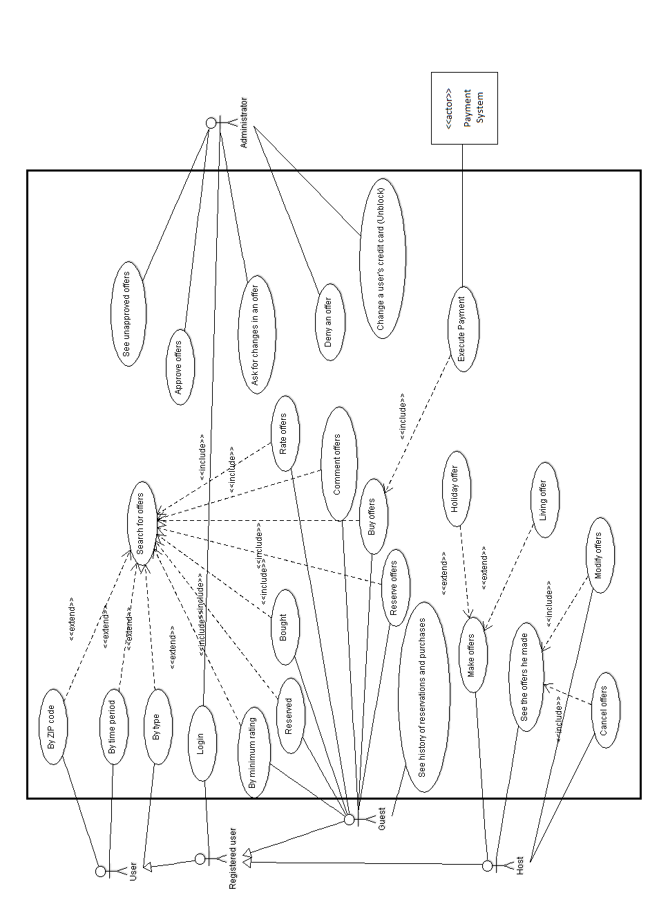

3.2 Use case descriptions

3.2.1 Use Case: Buy Offer
Primary Actor: Guest.
Stakeholders and Goals:
Guest: To purchase a specific offer that he has previously sought and maybe reserved.
Host: Wants his offer to be purchased.
Preconditions:
The user has logged in as a guest and has sought for the offer that he is to buy.
Success guarantee (Post-conditions):
The offer is modified in the system as “bought”, the needed data for the payment is sent to the payment system, the guest receives an invoice for its purchase in an e-mail with all the details and the host receives a notification that his offer has been purchased.
Main Success Scenario:
1.The guest user selects “Buy offer”.
2.The system checks that the offer is not already bought or reserved by another person.
3.The system checks whether the user data is correct or not.
4.The data is sent to the Payment System.
5.The invoice is sent via e-mail to the user as well as the details of the purchased offer.
6.The offer is modified by the system and is marked as “bought”.
7.The host receives a notification that his offer has been purchased.
Extensions (Alternative paths):
2a.The offer is already bought or reserved by another user.
2a.1.The user gets the text “The offer is not available”.
2a.2.The user returns to the search window.
3a.The user data is not correct.
3a.1.The user gets the text “Your data is not correct. Please, contact with the administrator in order to fix it”.
4a.The Payment System does not connect correctly with our system.
4a.1.The user gets the text “Sorry there was a connection problem, try again later”.
4a.2.The user returns to the offer window.
Special Requirements: None
Technology and Data Variations List:
Option to share on social networks information about the offer.
Frequency:
Hundreds or thousands times a day, with multiple users at the same time.
Open Issues: None

3.2.2 Use Case: Create Offer
Primary Actor: Host
Stakeholders and Goals:
Host: To make an offer of a house of his property to gain some benefit.
Administrator: Wants to check the new offers to approve them, deny them or ask for some changes.
Preconditions:
The user has logged in as a host.
Success guarantee (Post-conditions):
The offer and all its data are stored in the system and the administrator receives a notification to check the new offer.
Main Success Scenario:
1.The host user selects “Create offer”.
2.The user introduces all the house specifications (location, size…).
3.The system checks whether the user data is correct or not.
4.The user selects if the offer is for holiday or for living and provides the offer specifications (starting date, duration, conditions…).
5. The user click “Create offer” button in order to finish the offer creation.
6.The offer is stored in the system as “Not yet approved”.
7.The host gets a notification that confirms that the offer has successfully been made.
8.The administrator receives a notification to check the new offer.
Extensions (Alternative paths):
3a.The user data is not correct.
3a.1.The user gets the text “Your data is not correct. Please, contact with the administrator in order to fix it”.
Special Requirements: None
Technology and Data Variations List:
Option to pay in order to position your offer better on search results.
Frequency:
Hundreds times a day, with multiple users at the same time.
Open Issues: None

3.2.2 Use Case: Unblock user
Primary Actor: Administrator
Stakeholders and Goals:
Administrator: To unblock a given user so that he can use the application again.
User: Wants to be unblocked in order to be able to use the application again.
Preconditions:
The user has logged in as an administrator.
Success guarantee (Post-conditions):
The credit card number of the unblocked user is successfully changed, the user can enter the application and he gets a notification that he has been unblocked.
Main Success Scenario:
1.The administrator introduces the new user credit card number in the text box.
2.The administrator selects “Unblock user”.
3.The system checks that the new credit card number is correct.
4.The new credit card number is stored in the system.
5.The unblocked user is allowed to login into the application again.
6.The unblocked user gets a notification that he has been unblocked.
Extensions (Alternative paths):
3a.The introduced credit card is not correct.
3a.1.The administrator gets the text “the number introduced is not correct.
3a.2.The administrator returns to step 1.
Special Requirements:
The payment system must have a method that allow us to check the credit cards.
Technology and Data Variations List:
Option to share on social networks information about the offer.
Frequency:
Dozens times a day but just one by one.
Open Issues:
The administrator can’t directly contact to the user to advise him.

4. Mockups
4.1 Main screen for non-registered users.
Here you can see the main screen with the three types of searches.
Once they login on the left panel, they go to 4.3 if they are guests, to 4.8 if they are hosts, or to 4.10 if the user is the administrator. Once they search, they go to 4.2.
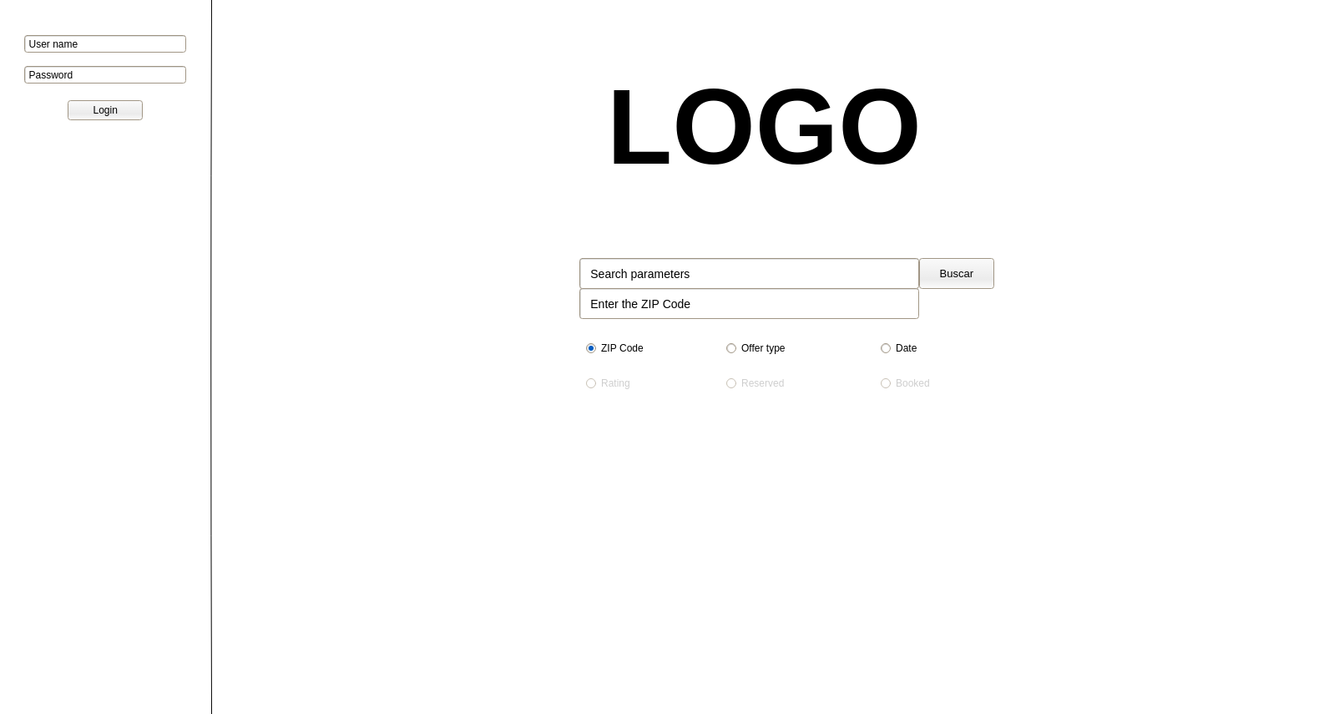
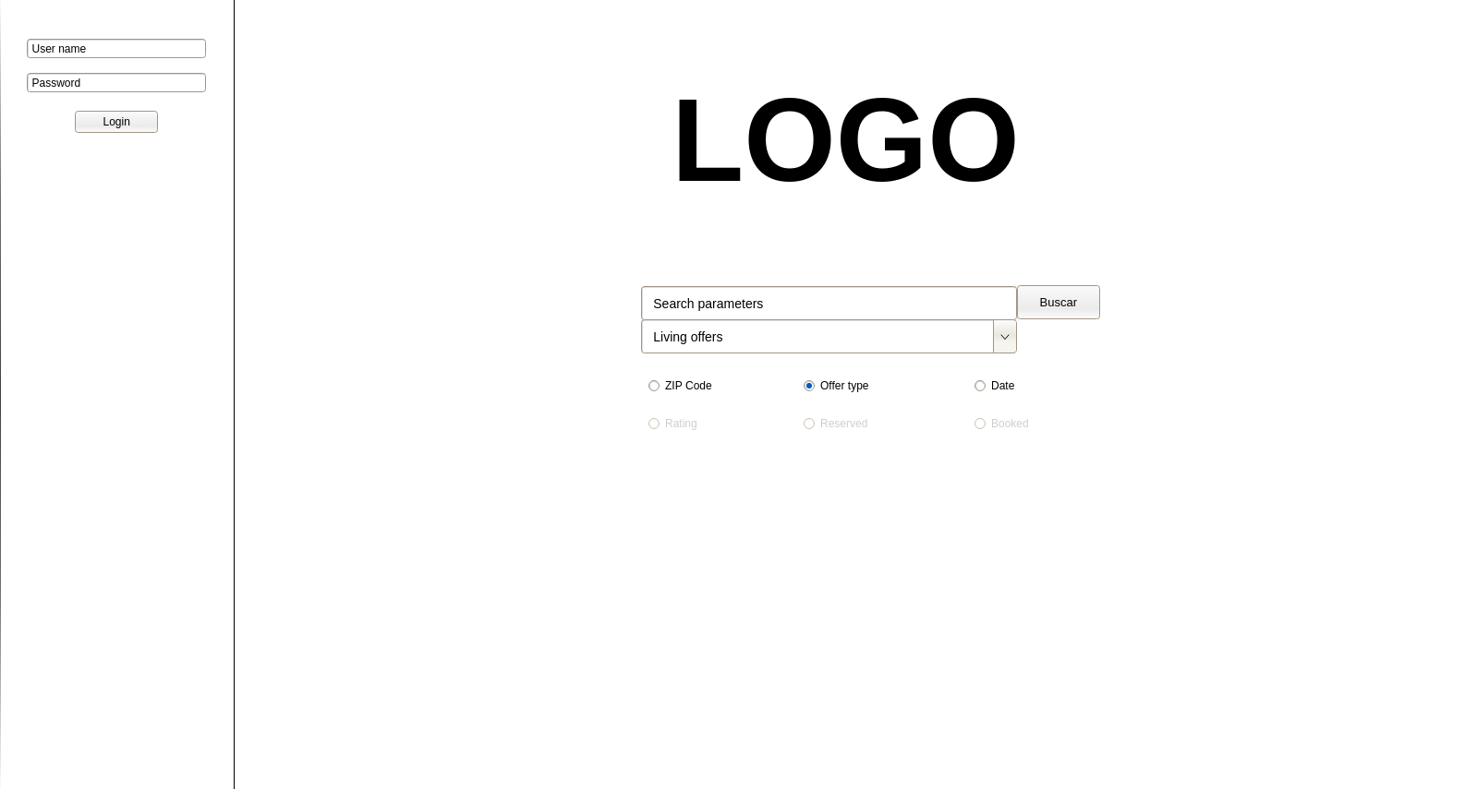

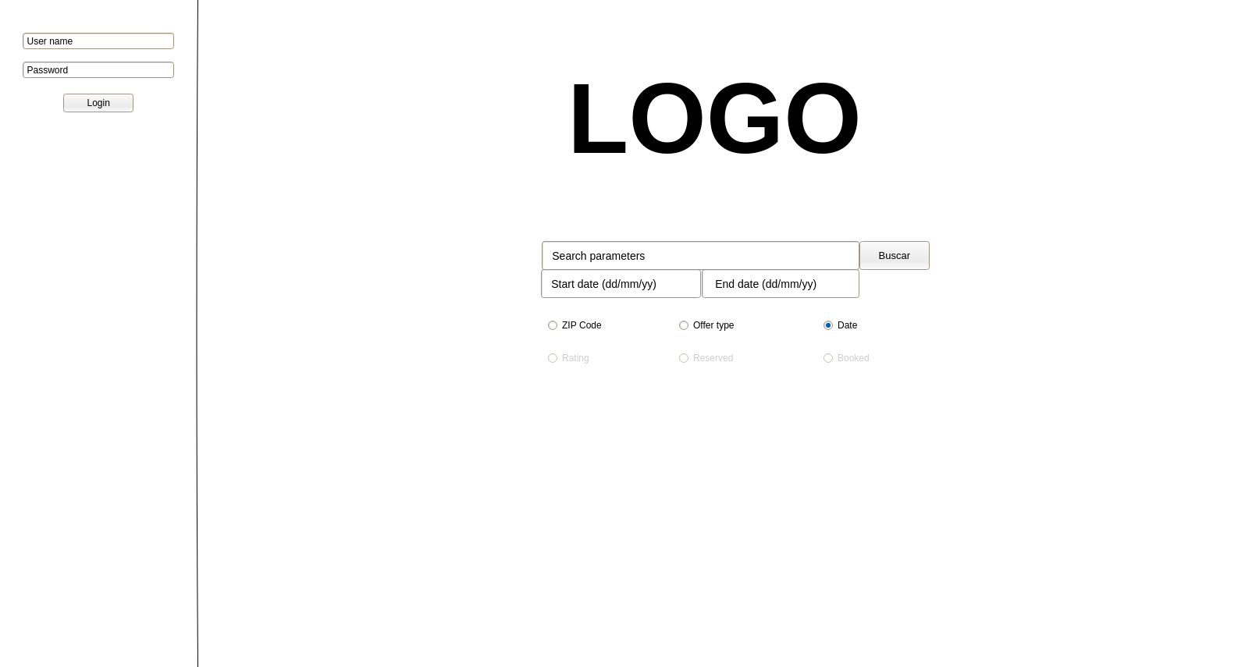
4.2 Search screen for non-registered users.
Once a non-registered user gets to this screen, they can’t do anything but login.
If the user login, he is redirected to 4.4.
Note that the price or the information about the offer availability is not shown.

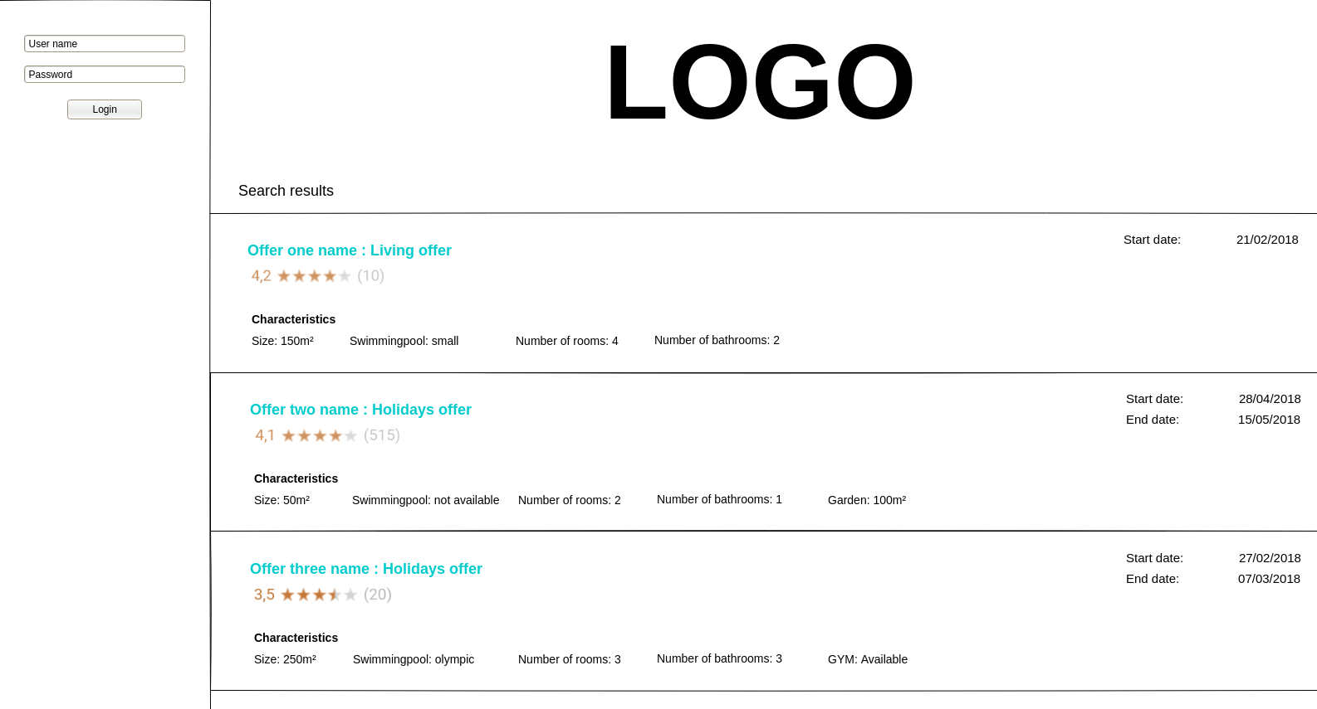

4.3 Main screen for registered users.
Once the user login, he can use more types of searches as the ones shown here as a example.
Note that there is a history button on the left panel that redirects the guest to 4.5.
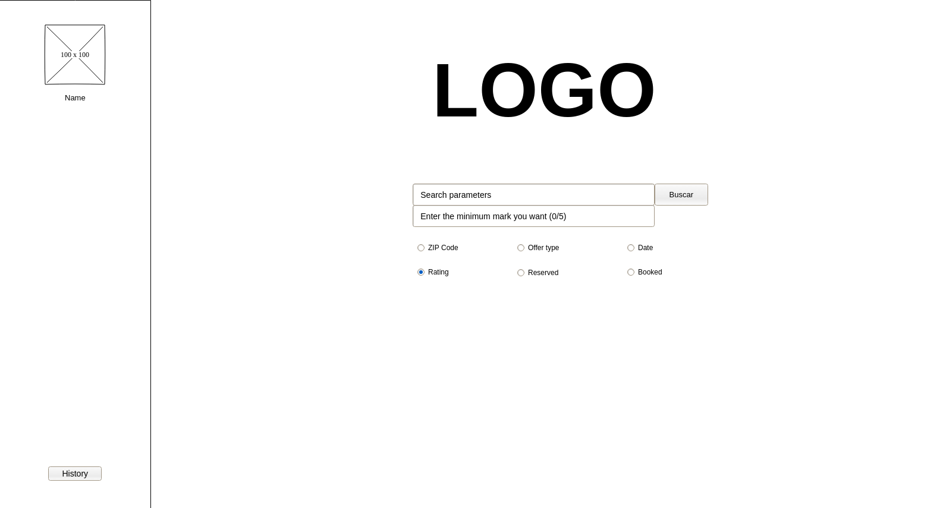

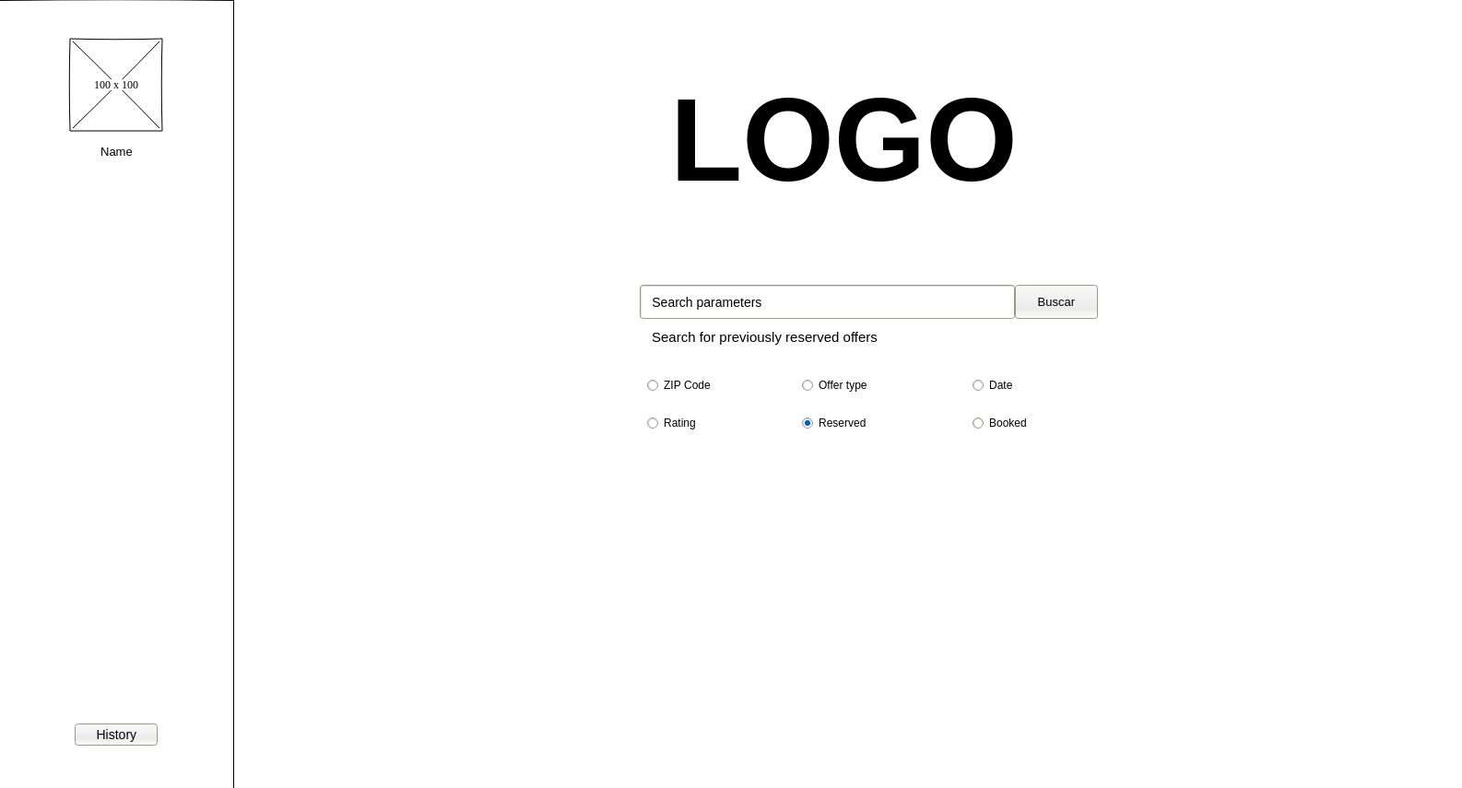

4.4 Search screen for registered users.
Once a registered user search something, he gets to this screen.
If he clicks in any of the offers, he is redirected to a screen like the one on 4.6.
Note that the price and the information about the offer availability is now shown.
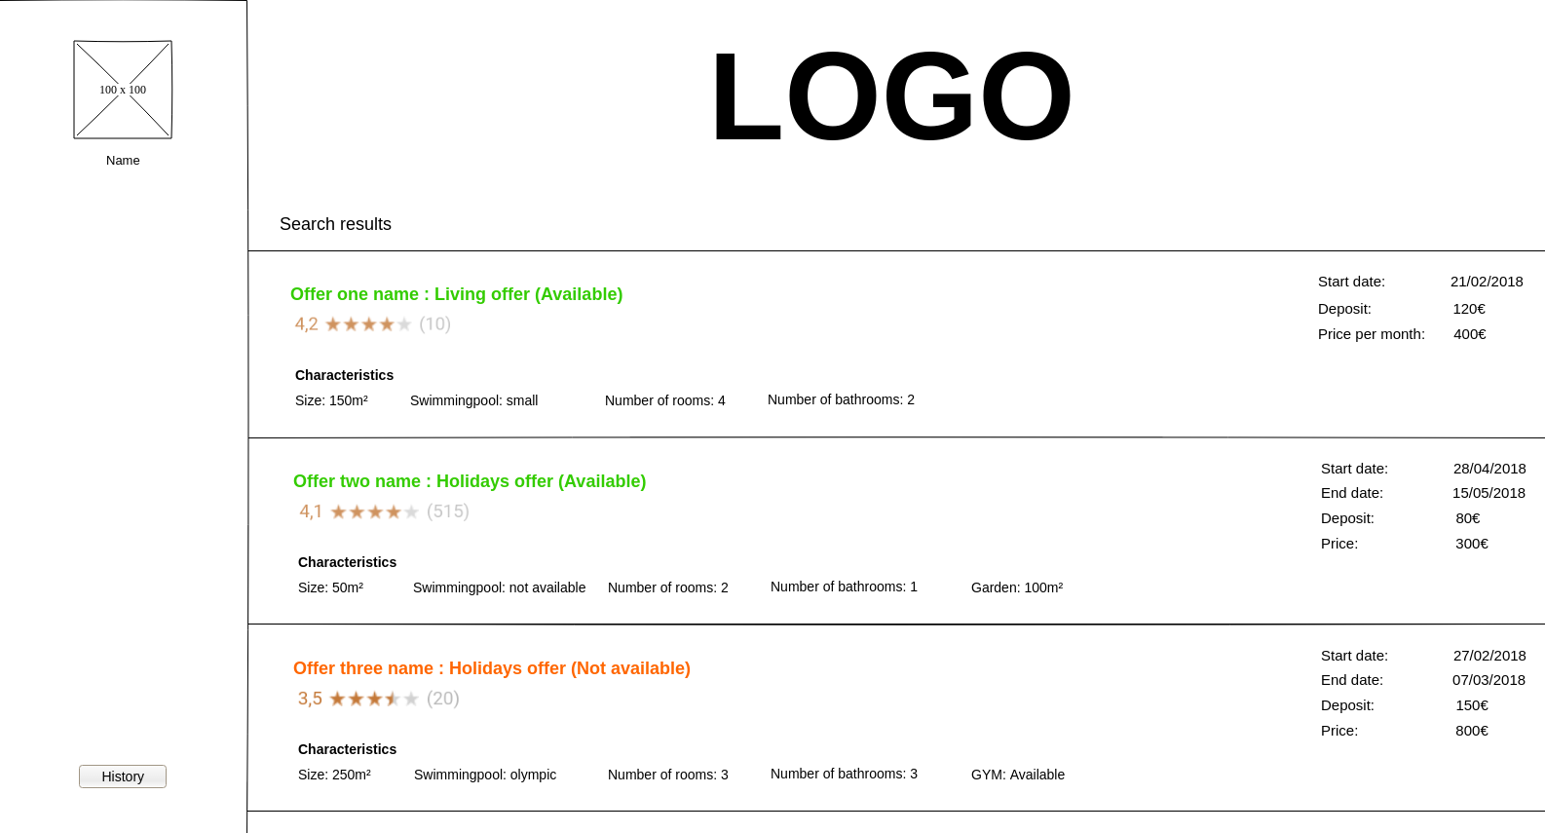

4.5 Guest history.
Once the guest clicks the history button on the left panel, he gets here, where he can see all his bought and reserved offers.
Note that the guest has a button to pay the reservation.
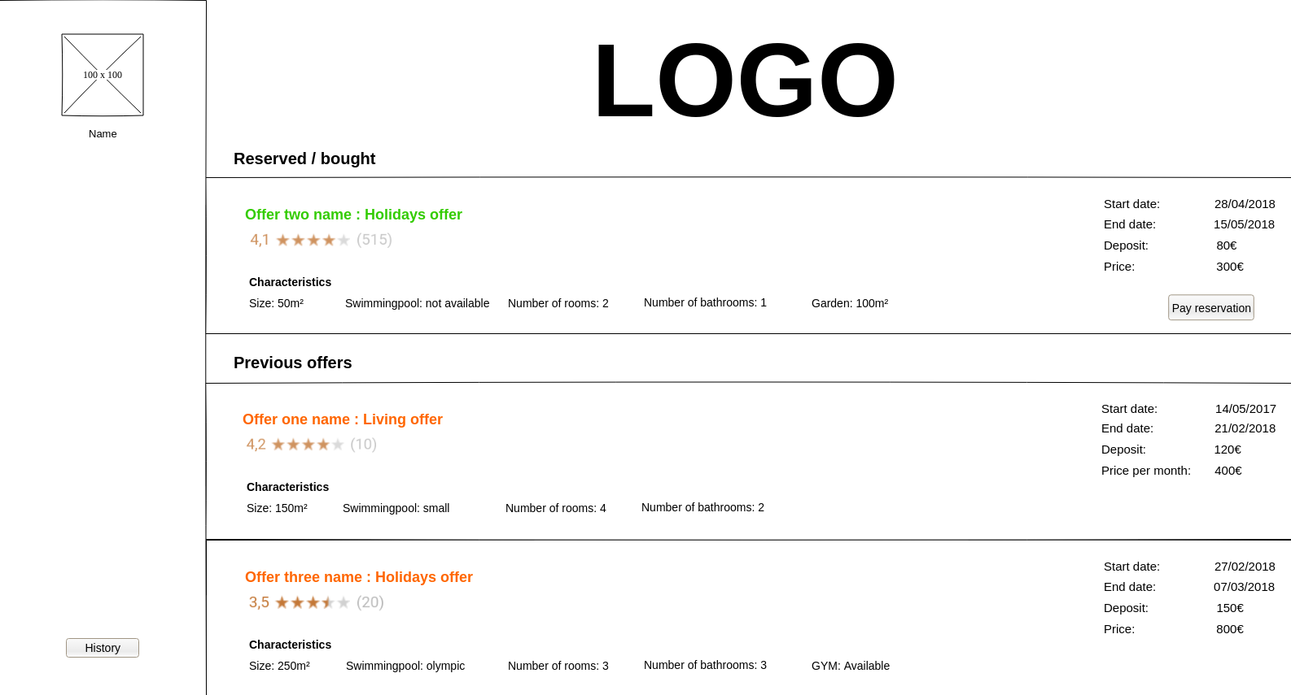

4.6 Offer preview
Here the guest can see all the information and comments on an offer. He can also rate the offer himself.
Once he clicks Comment/Rate button he goes to 4.7.
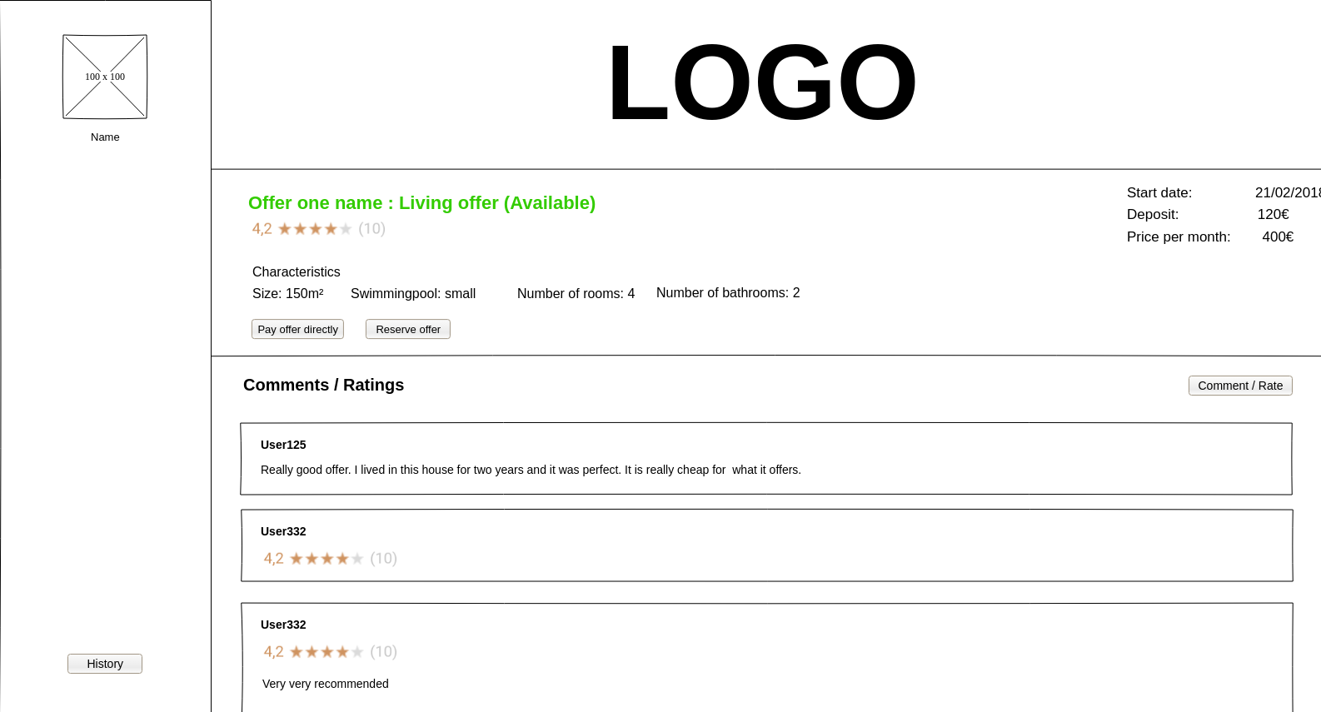
4.7 Comment window
Here the guest can comment and rate an offer.
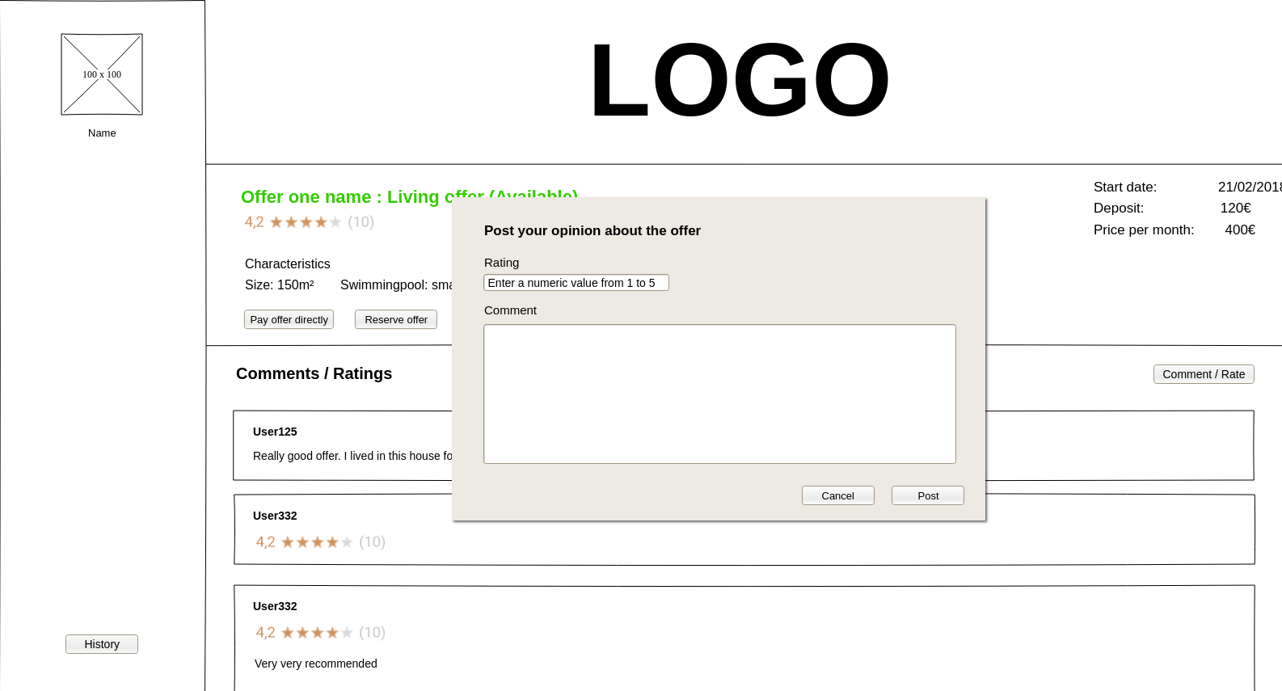

4.8 Host control panel
Here the host can see all his approved or not approved current and previous offers, and the changes he needs to do. By clicking on “Create offer” he goes to 4.9 and he can create new offers.
Note that the host can see why the administrator dismissed his offer, and as the offer is not approved yet, the host can still cancel it. Also, the left bar button now allows him to create a new offer.

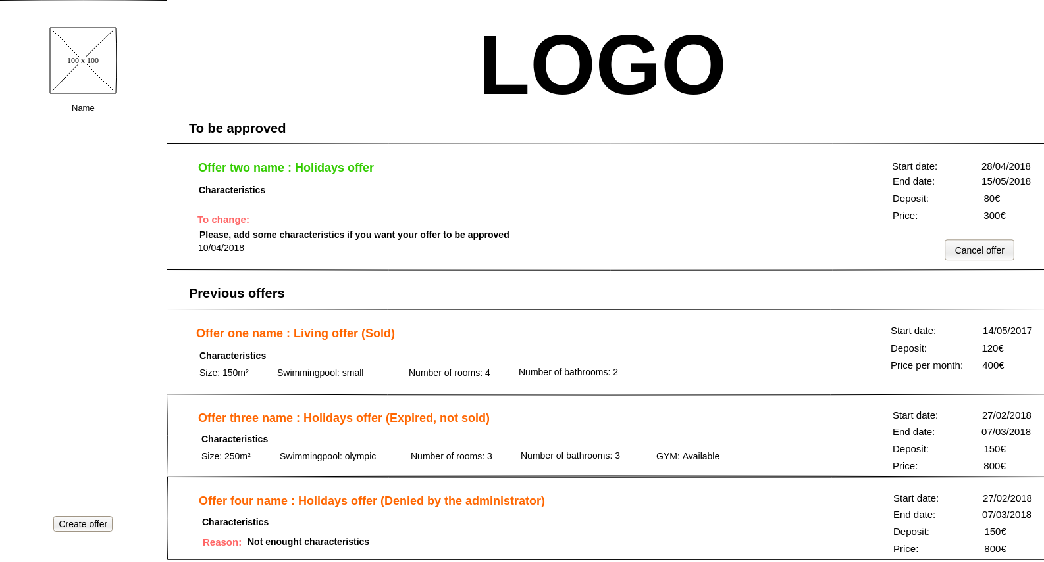
4.9 Host offer creation
Here the host can create new offers.
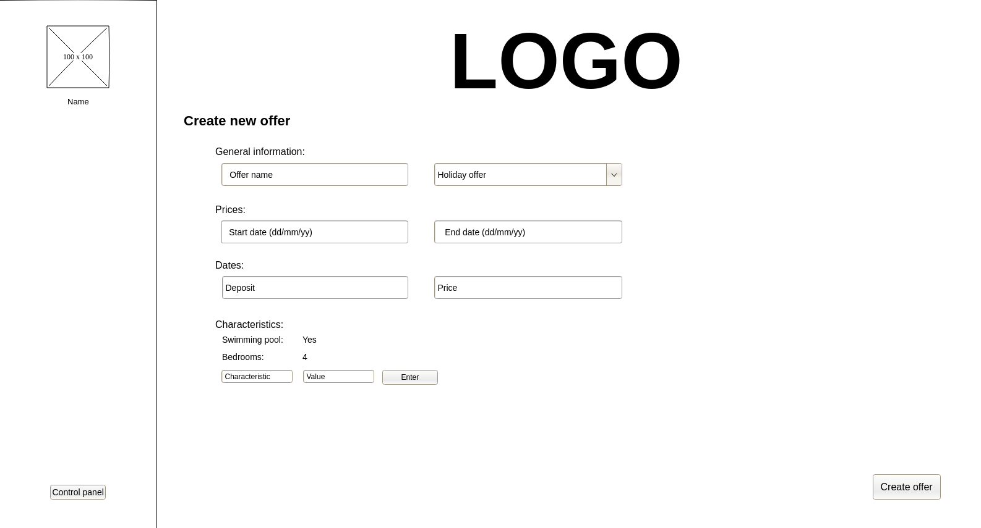

4.10 Administrator control panel
Here the system administrator can approve, deny or ask for changes the different offers. He can also unblock banned users by changing his credit card number.
